ĐẠI HỌC QUỐC GIA THÀNH PHỐ HỒ CHÍ MINH

TRƯỜNG ĐẠI HỌC CÔNG NGHỆ THÔNG TIN

KHOA HỆ THỐNG THÔNG TIN



**React Native Programming**

**Food Temperature App**

**Lecturer:** ***Huỳnh Tuấn Anh***

Thực hiện

* Ngô Tiến Lộc MSSV: 15520429

**Food Temperature App**

1. **App Overview**

* Using React Native version 0.49
* First look

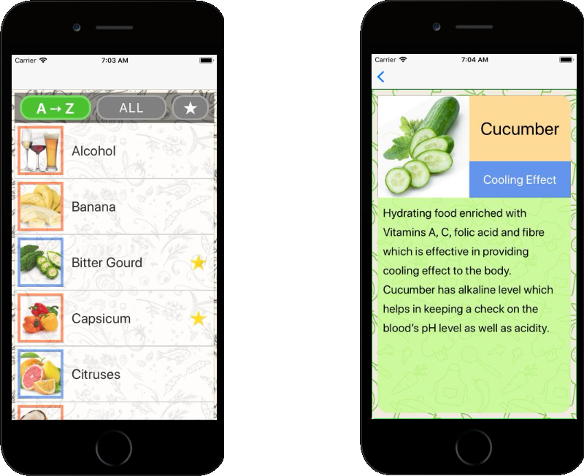

1. **App Manuals**

* ListScreen

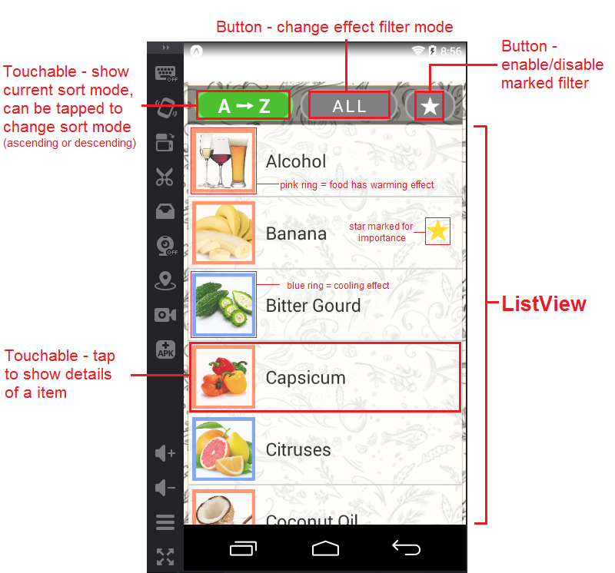

* Move between screen

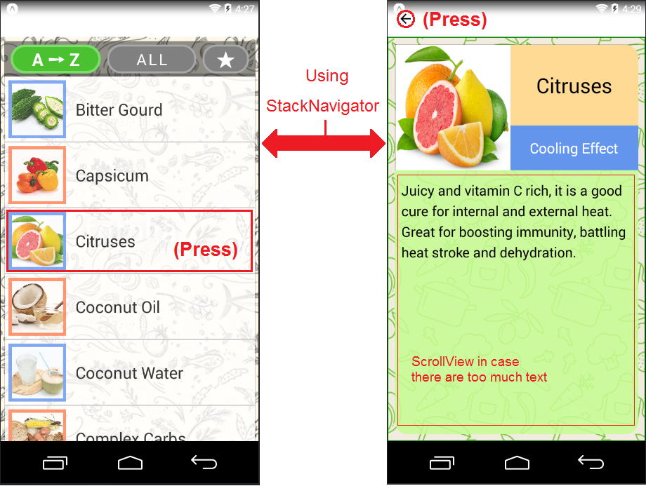

*ListScreen DetailScreen*

* Items filtering
* Filtering order:
  + Items from data

➡ favourite filter (filtering marked items)

➡ effect filter (based on a effect the food has)

➡ sorting

➡ items for display

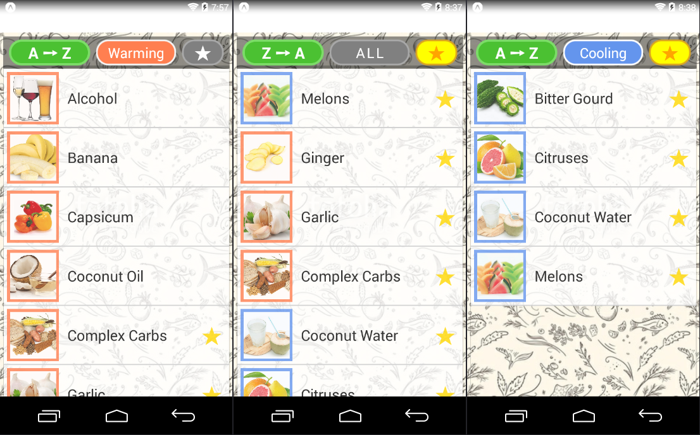

*Different kinds of filterings*

* Mark/unmark an item

1. Choose an item in ListScreen
2. Press and hold that item for 3 seconds
3. If you mark an item, there will be an alert

If you unmark an item, a star next to its name will disappear

* + Marked data of an item is stored on device via AsyncStorage

